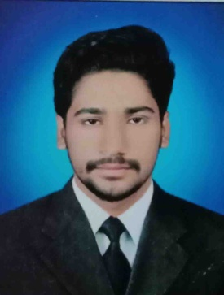

**Address:**Muhalla Eid Gah Station Road P.O Pano Akil, Taluka Pano Akil District Sukkur

Cell: 0304-0032028

Email: [adnanarain1101@gmail.com](mailto:adnanarain1101@gmail.com)

adnan jameel

***CAREER OBJECTIVE:***

Seeking for job related to my qualification I performance oriented organization and to become an active part of an organization that offers a challenging position in a good working environment where I can share my professional qualification, knowledge, skills and ability.

***PERSONAL INFORMATION:***

* F/Name : Muhammad Jameel
* Surname : Arain
* Date of Birth : 05-01-2001
* CNIC No : 45501-9257701-5
* Domicile/PRC : Sukkur
* Nationality : Pakistani
* Religion : Islam
* Marital Status : Single

***ACADEMIC QUALIFICATION***

|  |  |  |  |
| --- | --- | --- | --- |
| Degree / Certificate | Grade / Division | Board/ University | Passing year |
| Matriculation | “B” Grade | BISE Sukkur | 2016 |
| Intermediate | “B” Grade | BISE Sukkur | 2018 |
| B.Sc | “First” Division | SALU Khairpur | 2021 |
| BS Computer Science | 3rd Semester | Virtual University | 2025 |

***OTHER QUALIFICATION***

* Information Technology (C.I.T), In New Islamic Institute of Information Technology Pano Akil.
* Computer Application & Office Professional, In Pano Akil Institute of Technical Education (PITE), Pano Akil Cantonment.

***Skills***

* Frontend Web Developer. HTML, CSS, JavaScript, Bootstrap and React.JS.

***Experience***

* Frontend Website Development Since 2021 as a Freelancer on Fiverr and Upwork .

***LANGUAGES***

* English,
* Urdu,
* Sindhi.

***STRENGTHS***

* Self motivated.
* Good interpersonal skills.
* Team working.

***REFERENCE***

* Will be furnished on demand.